Make sure to download the DESIGN TRENDS 2020 zip file which contains a few of the downloadable resources talked about in the lessons. These are the links to external helpful resources. The student projects are outlined in detail below on page 2!

Trends in Typography
Variable Fonts
Getting started with Variable fonts
https://speckyboy.com/variable-fonts/
Test them out in the Font Playground
https://play.typedetail.com
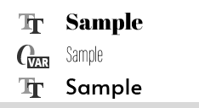
Another variable font to download
http://koe.berlin/variablefont/
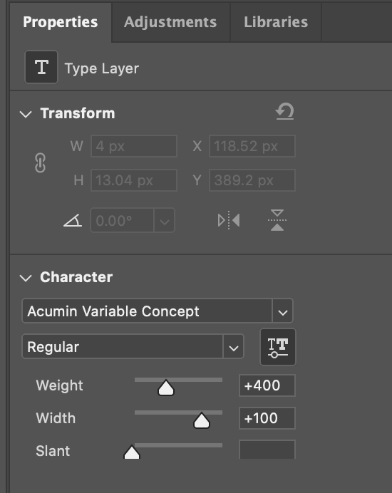
HOW TO USE VARIABLE FONTS
Requires photoshop version 2018 or newer to load variable fonts
Adobe Photoshop
1.) Download and install a variable font just like you would any other font. In your font list you will now notice this VAR symbol next to the font.
2.) Go over to your properties panel to be able to have extra adjustments not available on other standard fonts.

Hand Drawn Assets
Wedding Photo - https://www.pexels.com/photo/woman-sitting-on-red-lounger-2846544/

Magazine Mockup - https://graphicburger.com/?s=magazine

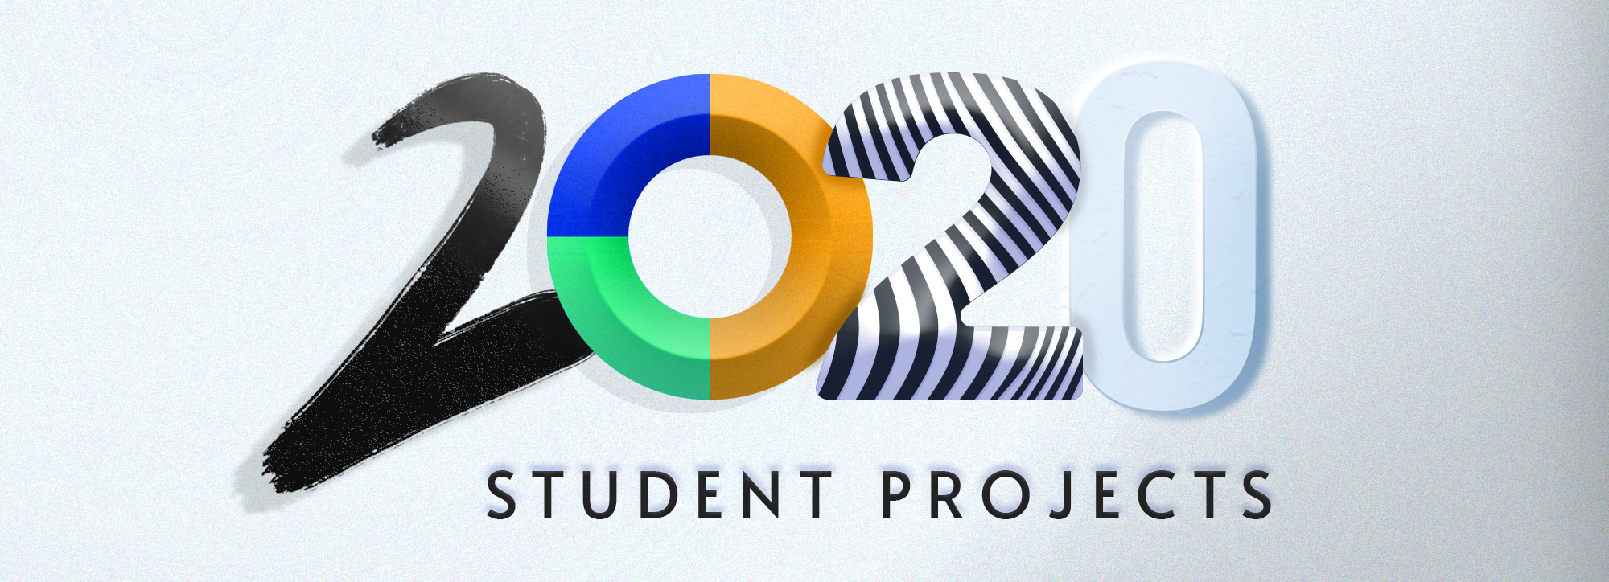
Make sure to download the zip file to the left of the project section of the course to have access to some of the course files and links.

You have been tasked in each lesson with a unique project! Feel free to pick one of your choice to post in the project section (Q&A) of this class (although if you post multiple that is wonderful too!). You can also post it in the student Facebook group.

1.) A Distorted Typography Poster
Your task is to create a poster using distorted or warped text using the envelope distort tool in Adobe Illustrator. You can do a simple word or a repeated word block of type.

2.) Create a Skeuomorphism Style Button or UI Element
Feel free to do this in your program of choice. Create a realistic UI element or button using the methods we reviewed in the lesson. Feel free to use highlights and shadows to create buttons, knobs, dials and more.

3.) Create and Use Hand-drawn Assets
Use a digital sketching app, or a Wacom tablet, or you can even use traditional methods like watercolor or pen and paper to create a few hand-drawn graphics. As a bonus, you can use those hand-drawn assets in a design piece of any kind.

4.) Create a frame animation GIF in Photoshop
Create at least a 2-8 frame animated GIF using the Photoshop timeline feature. It can be a social media graphic or a GIF to show off your work.

5.) Create an Abstract Geometric Poster
Using only circles, create a geometric design poster by cutting out shapes and arranging them using the Grid system.

